**Experiment No. 10** 

### Name: Rebecca Dias Roll No.: 19 Class: BE CMPN A PID: 182027

**Aim:** To study and implement Histogram Processing..

**Theory:**

* What is Histogram Processing?

In an image processing context, the histogram of an image normally refers to a histogram of the [pixel intensity values](https://homepages.inf.ed.ac.uk/rbf/HIPR2/value.htm). This histogram is a graph showing the number of [pixels](https://homepages.inf.ed.ac.uk/rbf/HIPR2/pixel.htm) in an image at each different intensity value found in that image. For an 8-bit [grayscale image](https://homepages.inf.ed.ac.uk/rbf/HIPR2/gryimage.htm) there are 256 different possible intensities, and so the histogram will graphically display 256 numbers showing the distribution of pixels amongst those grayscale values. Histograms can also be taken of [color images](https://homepages.inf.ed.ac.uk/rbf/HIPR2/colimage.htm) --- either individual histograms of red, green and blue channels can be taken, or a 3-D histogram can be produced, with the three axes representing the [red, blue and green](https://homepages.inf.ed.ac.uk/rbf/HIPR2/rgb.htm) channels, and brightness at each point representing the pixel count. The exact output from the operation depends upon the implementation --- it may simply be a picture of the required histogram in a suitable image format, or it may be a data file of some sort representing the histogram statistics.

* Importance of Histogram Processing
  1. In digital image processing, histograms are used for simple calculations in software.
  2. It is used to analyze an image. Properties of an image can be predicted by the detailed study of the histogram.
  3. The brightness of the image can be adjusted by having the details of its histogram.
  4. The contrast of the image can be adjusted according to the need by having details of the x-axis of a histogram.
  5. It is used for image equalization. Gray level intensities are expanded along the x-axis to produce a high contrast image.
  6. Histograms are used in thresholding as it improves the appearance of the image.
* Linear stretching(Explain using numerical)

 Way to increase dynamic range also known as Histogram stretching.We do not alter the shape of the histogram, but we spread it so as to cover the entire dynamic range.

We do this by using a straight line equation having slope:

(smax-smin)/(rmax-rmin)

Where,

smax=>Maximum gray level of output image

smin=>Minimum gray level of output image

rmax=>Maximum gray level of input image

rmin=>Minimum gray level of input image

**s=T( r)=((smax-smin)/(rmax-rmin))*(r-rmin)+smin**

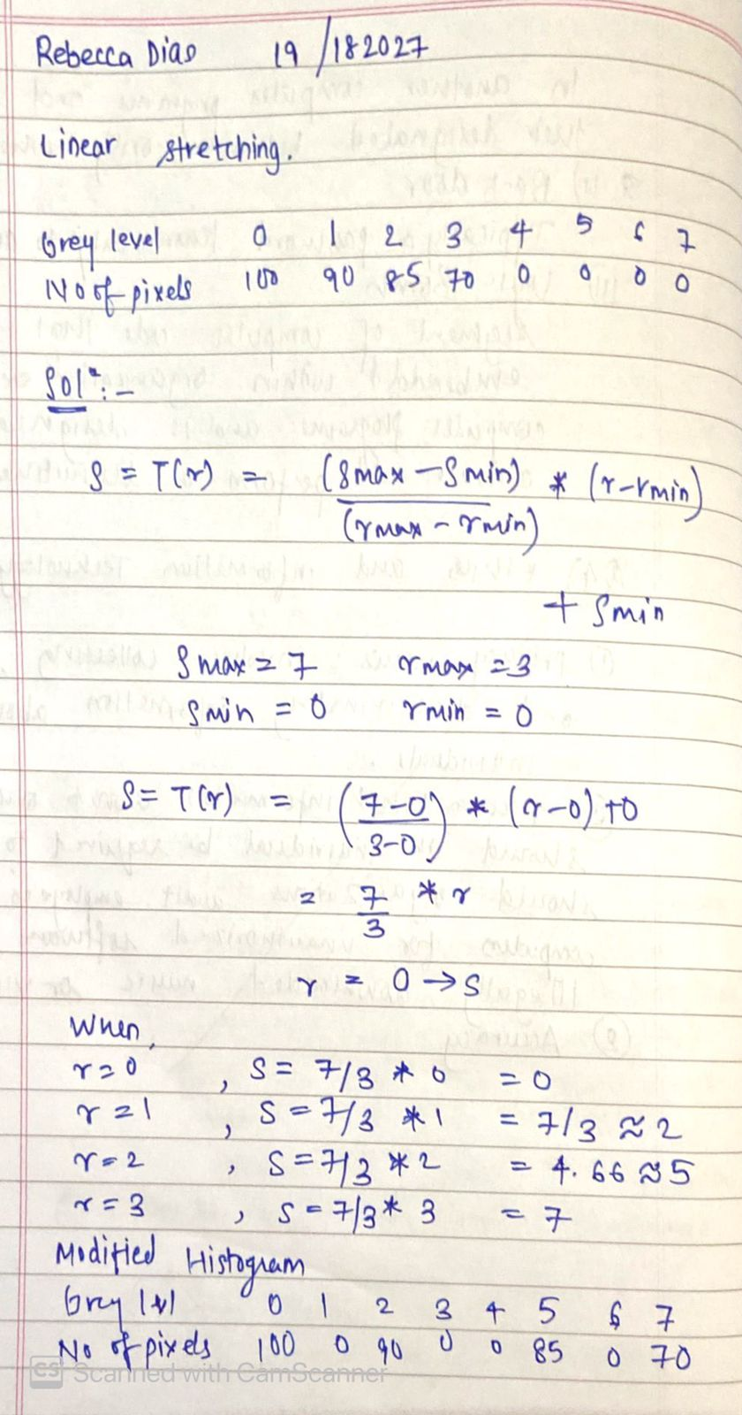

**Implementation:**

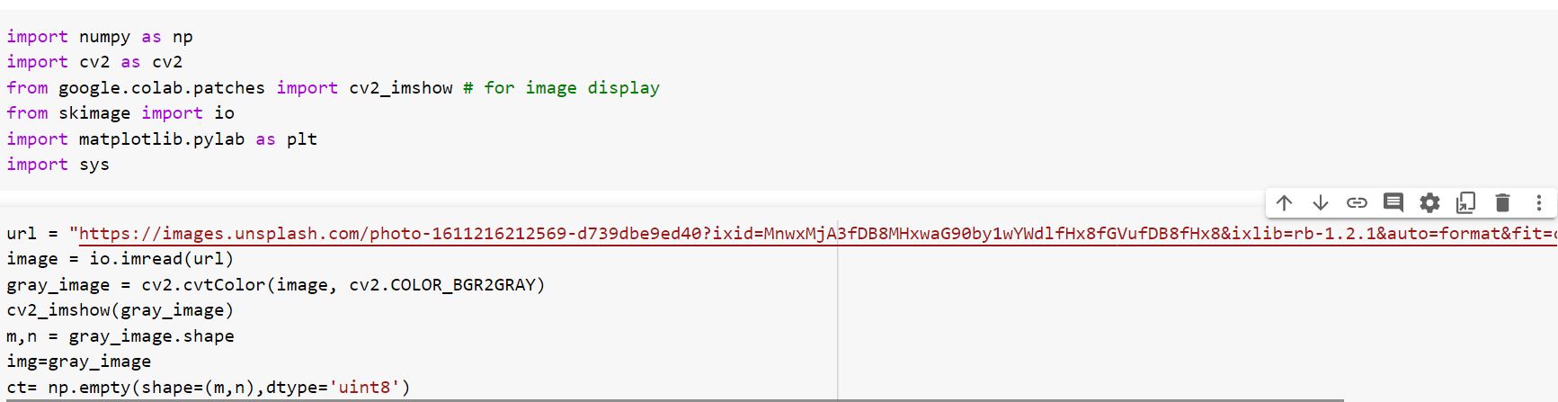



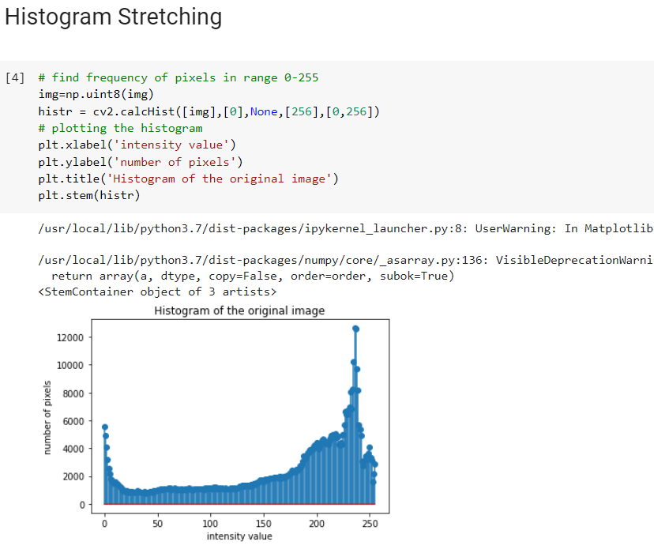 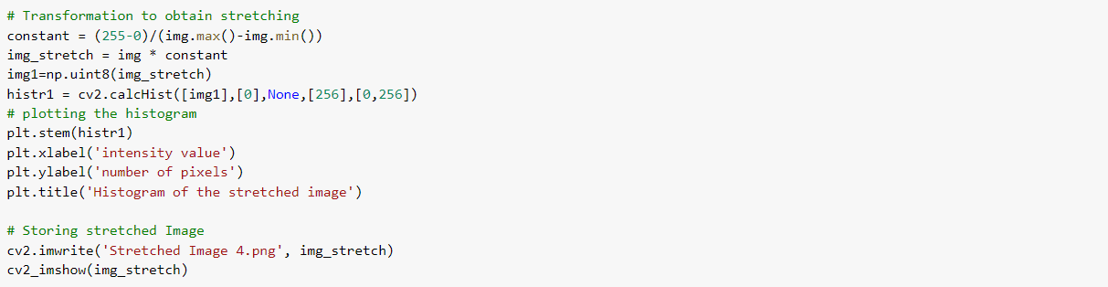  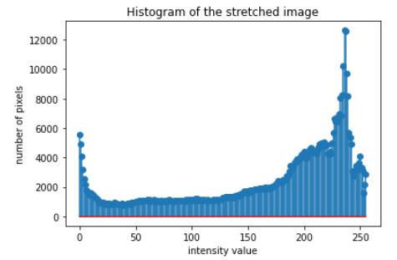 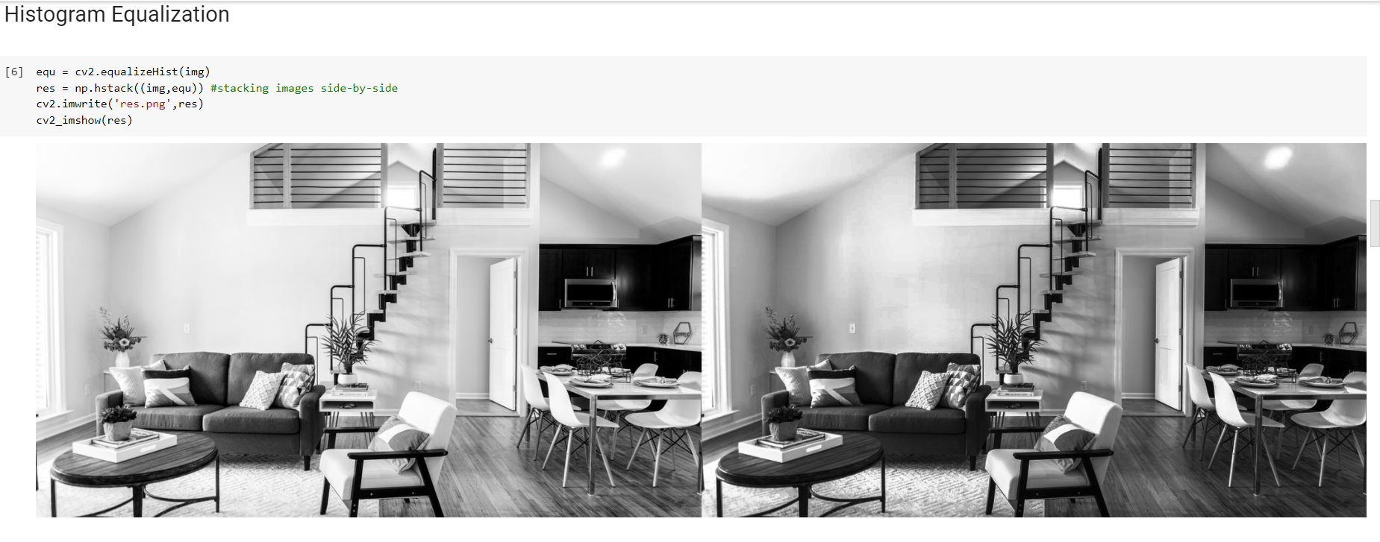 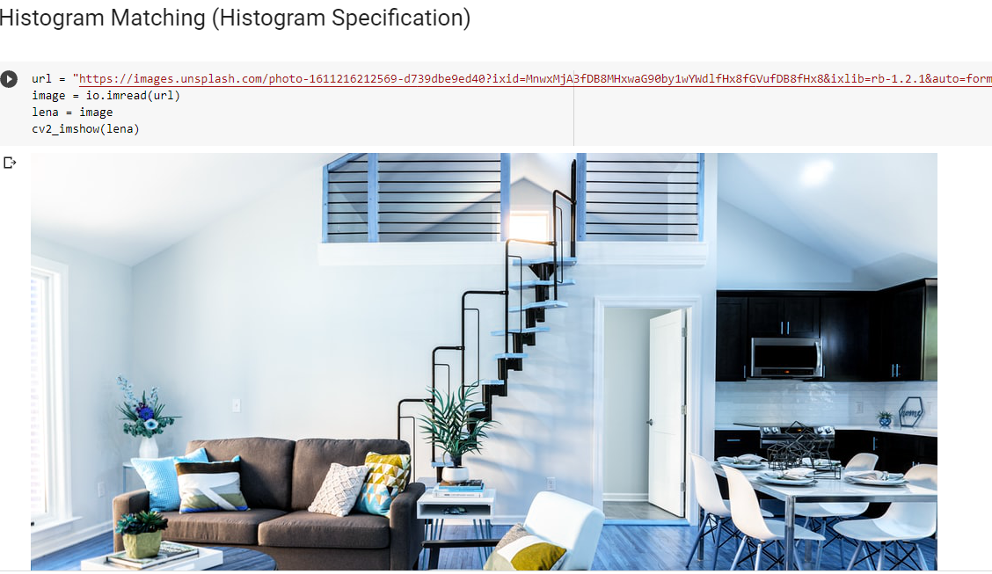 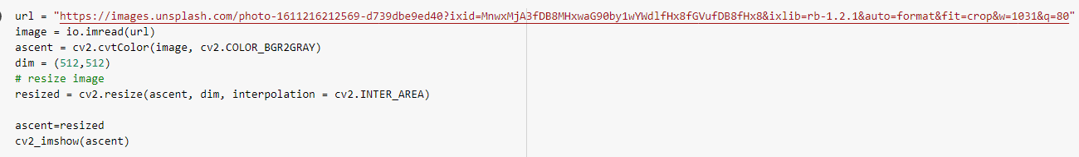 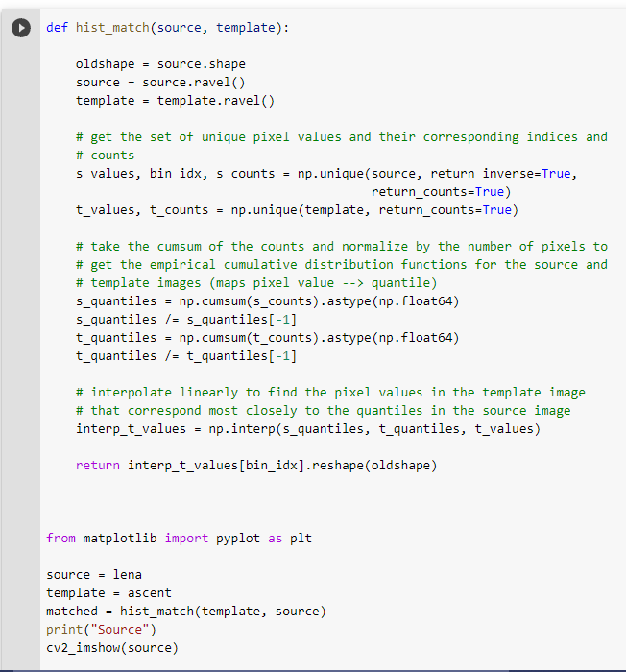  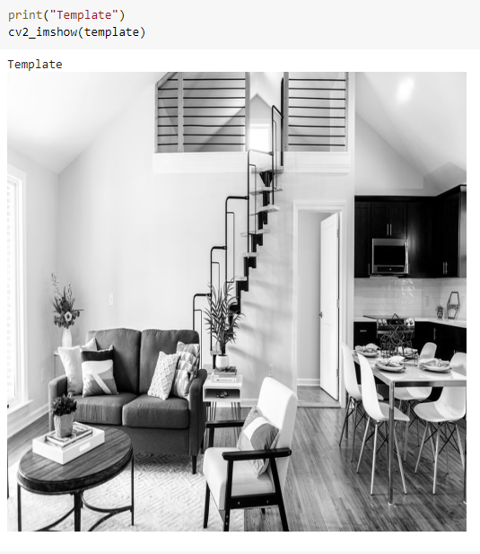 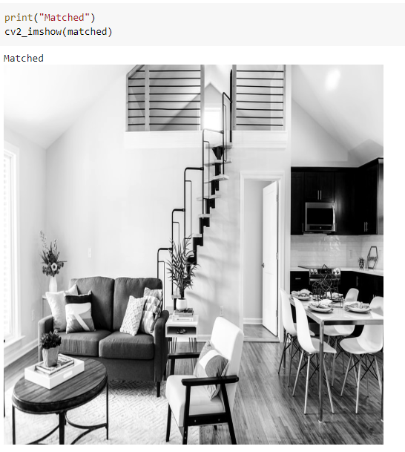

**Conclusion:**

In this Experiment We learned about Histogram Processing,in an image processing context, the histogram of an image normally refers to a histogram of the [pixel intensity values](https://homepages.inf.ed.ac.uk/rbf/HIPR2/value.htm).In digital image processing, histograms are used for simple calculations in software.It is used to analyze an image. Properties of an image can be predicted by the detailed study of the histogram.We also implemented the same in python and successfully got the output.